SOLAR-ASSISTED ELECTRIC CAR — FULL PROJECT DESCRIPTION

Project Title :
Solar-Assisted Electric Car Prototype: An Embedded Systems Approach to Sustainable Vehicle Technology
Project Overview:
This project is a miniature working prototype of a solar-powered electric vehicle (EV) built using accessible embedded hardware. It demonstrates how renewable solar energy can be harvested, stored in a lithium-ion battery, and used to drive DC motors — mirroring the core architecture of real-world electric vehicles at a prototype scale.
The system integrates energy harvesting, battery management, motor control, and microcontroller logic into a cohesive, functional unit mounted on an EV car chassis.
Objectives:
Demonstrate real-world application of solar energy in mobile systems
Implement embedded motor control using PWM signals
Showcase a complete energy chain: Solar → Battery → Controller → Motor
Provide a platform for testing EV-related concepts like regenerative logic, speed control, and energy monitoring
Build a low-cost, educational prototype suitable for academic presentation

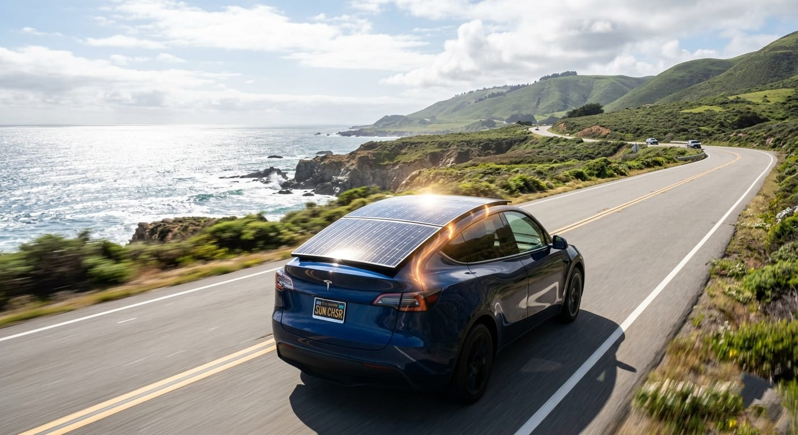

This image shows a futuristic electric vehicle (EV) designed to harness the power of sunlight while driving along a scenic coastal road. The car is equipped with a sleek, integrated solar panel mounted on its roof, which captures energy directly from the sun.
As the vehicle moves, the solar panel absorbs sunlight and converts it into electrical energy using photovoltaic cells. This energy is then either used immediately to support the car’s motor or stored in the onboard battery for later use. The system helps extend the driving range, reduce dependency on charging stations, and improve overall energy efficiency.
The design represents a step toward self-sustaining transportation, where clean, renewable solar energy contributes to powering the vehicle. While the main propulsion still relies on the electric battery, the solar input acts as a continuous supplementary power source—especially useful during long drives in sunny environments.
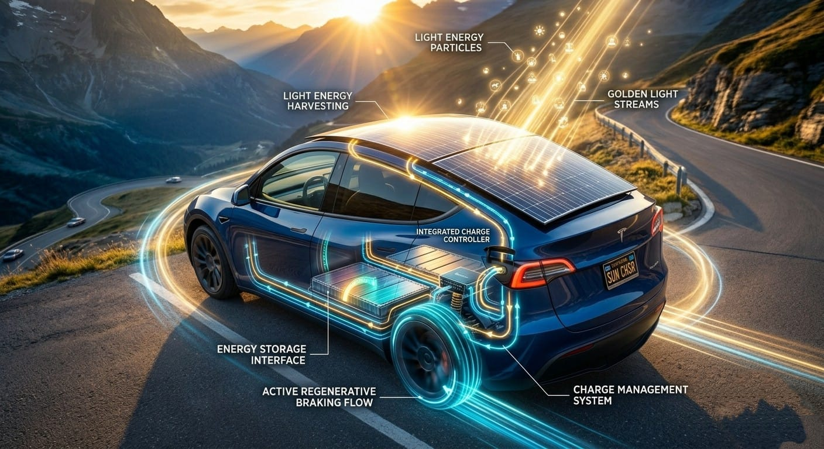

• Solar Energy Collection (Light Energy Harvesting)
The car’s roof is covered with solar panels that capture sunlight. These panels convert light energy (photons) into electrical energy using photovoltaic cells.
• Energy Conversion & Flow
The captured solar energy flows through an integrated charge controller, which regulates voltage and ensures safe energy transfer.
• Energy Storage (Battery System)
The electricity is stored in the vehicle’s battery pack through an energy storage interface. This stored energy is then used to power the electric motor.
• Powering the Motor
The battery supplies electricity to the motor, which drives the wheels—allowing the car to move smoothly without fuel.



Use of Electrical Energy for Other Purposes
Apart from moving the vehicle, the generated and stored electrical energy is also used for multiple internal and external functions:

🔌 1. Infotainment & Mobile Charging
- Charging smartphones, laptops, and gadgets
- Running music systems, navigation, and displays

🌡️ 2. Climate Control System
- Powering AC, heater, and ventilation
- Maintains comfortable cabin temperature

💡 3. Interior & Exterior Lighting
- Dashboard lights, ambient lighting
- Headlights, indicators, brake lights

